**Git and git hub task 2**

**1)Install git.**

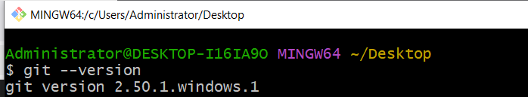

**2)Create a repo in github with README.md and .ignore file.**

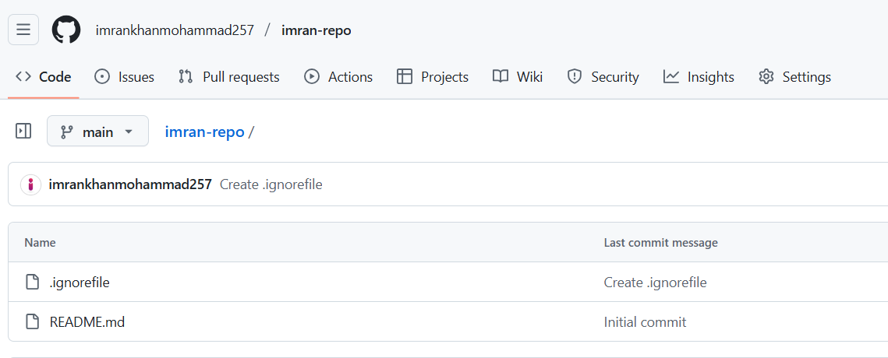

**3)Clone the created repo to local.**

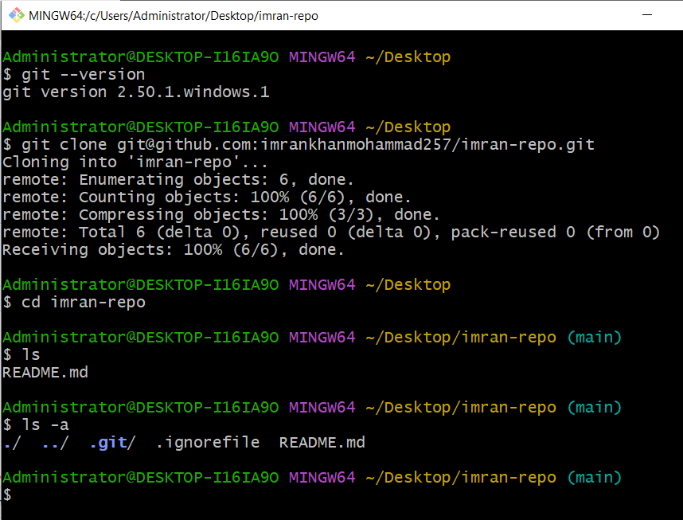

**4)Create two files in local repo.**

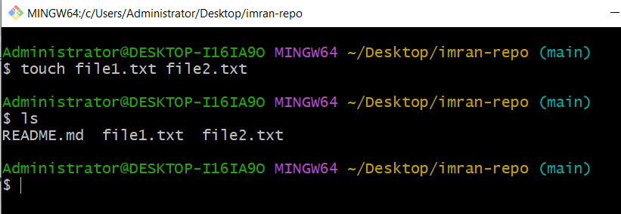

**5)Commit two files and push to central Repository.**

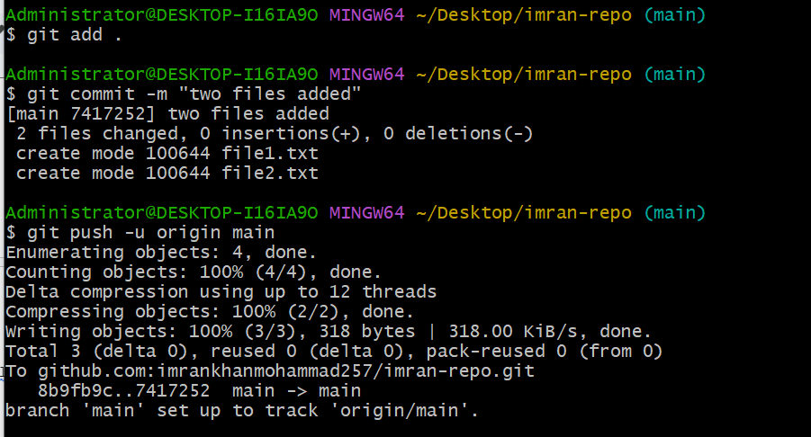

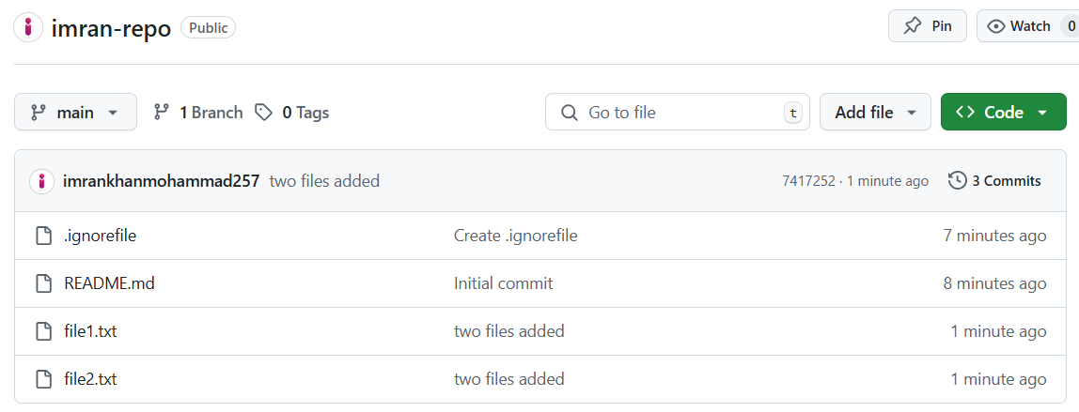

**6)Create a branch in local and create a sample file and push to central.**

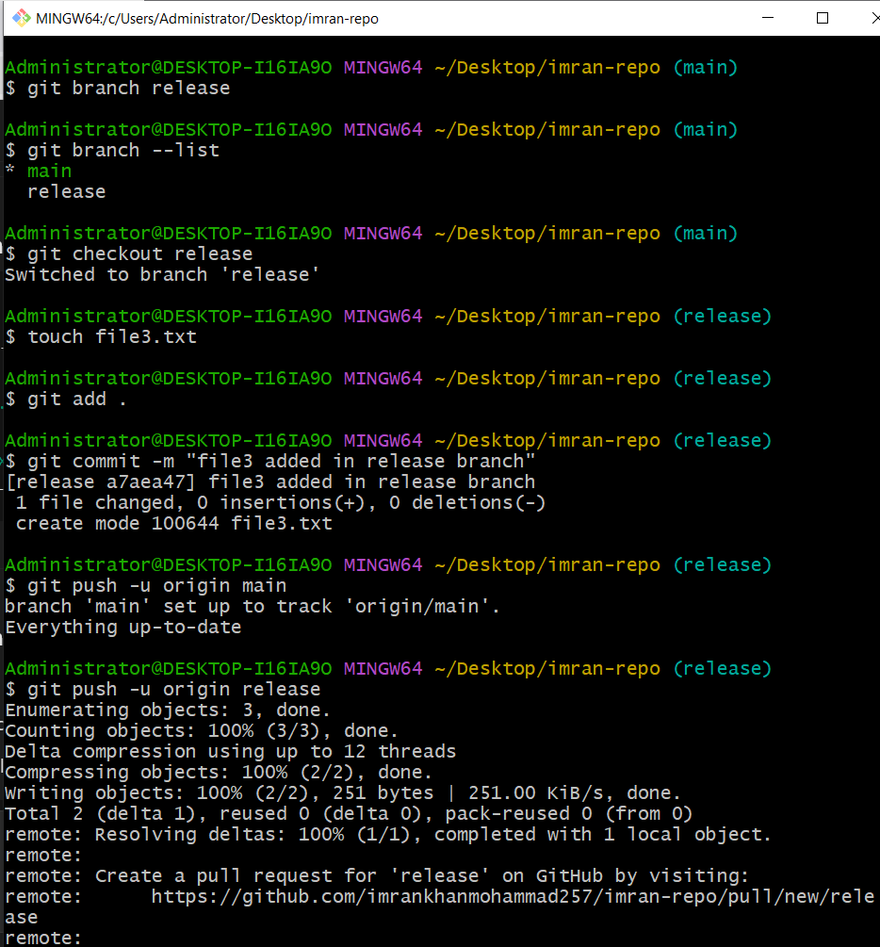

**7)Create a branch in github and clone that to local.**

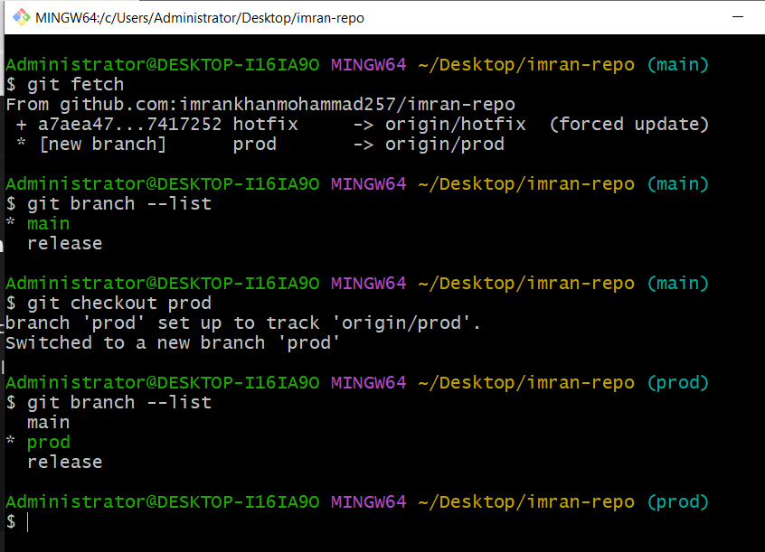

**8)Merge the created branch with master in git local.**

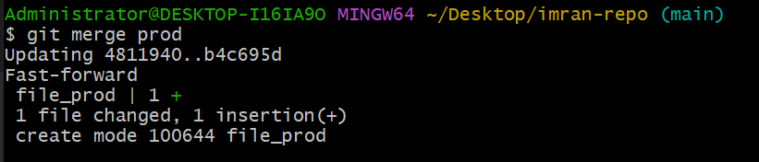

**9)Merge the created branch with master in github by sending a pull request.**

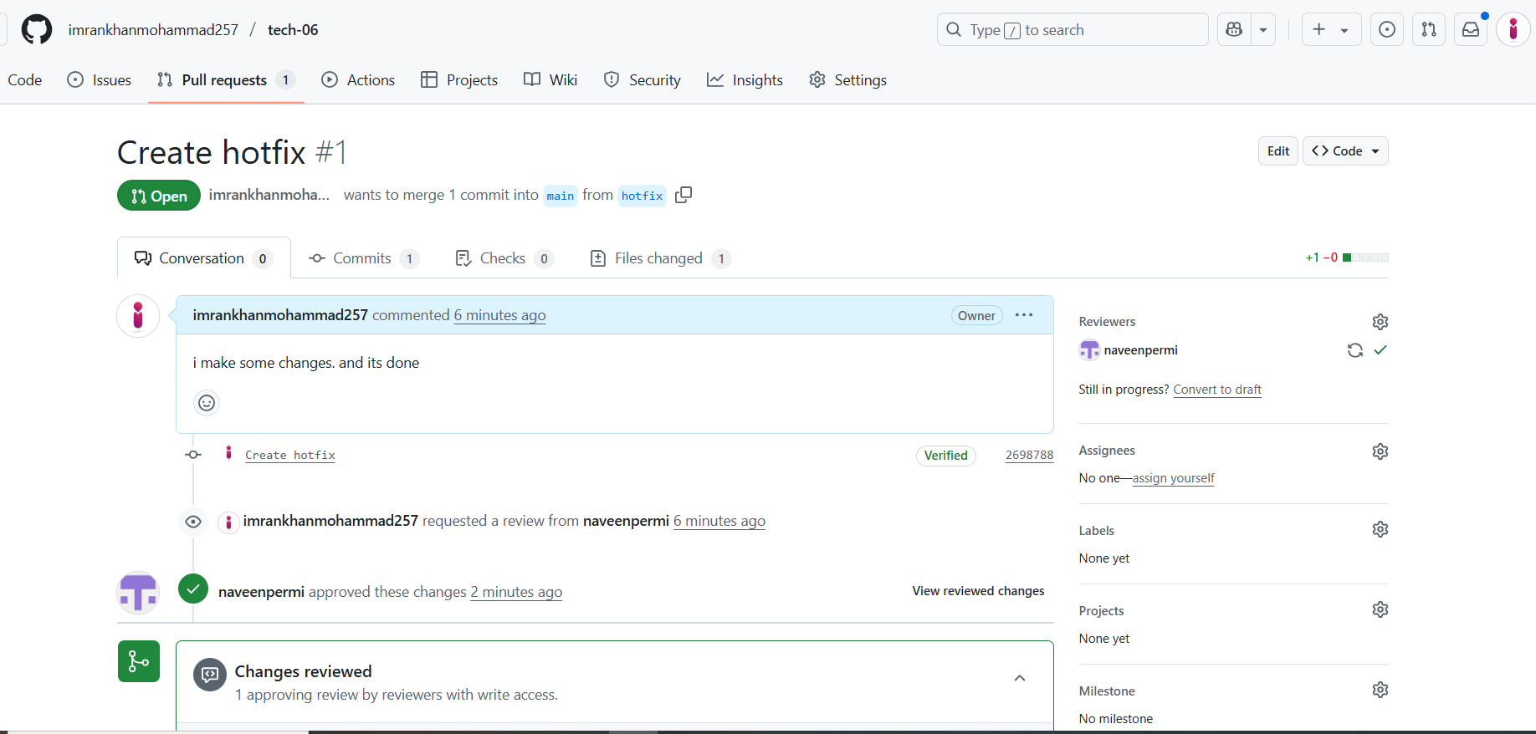

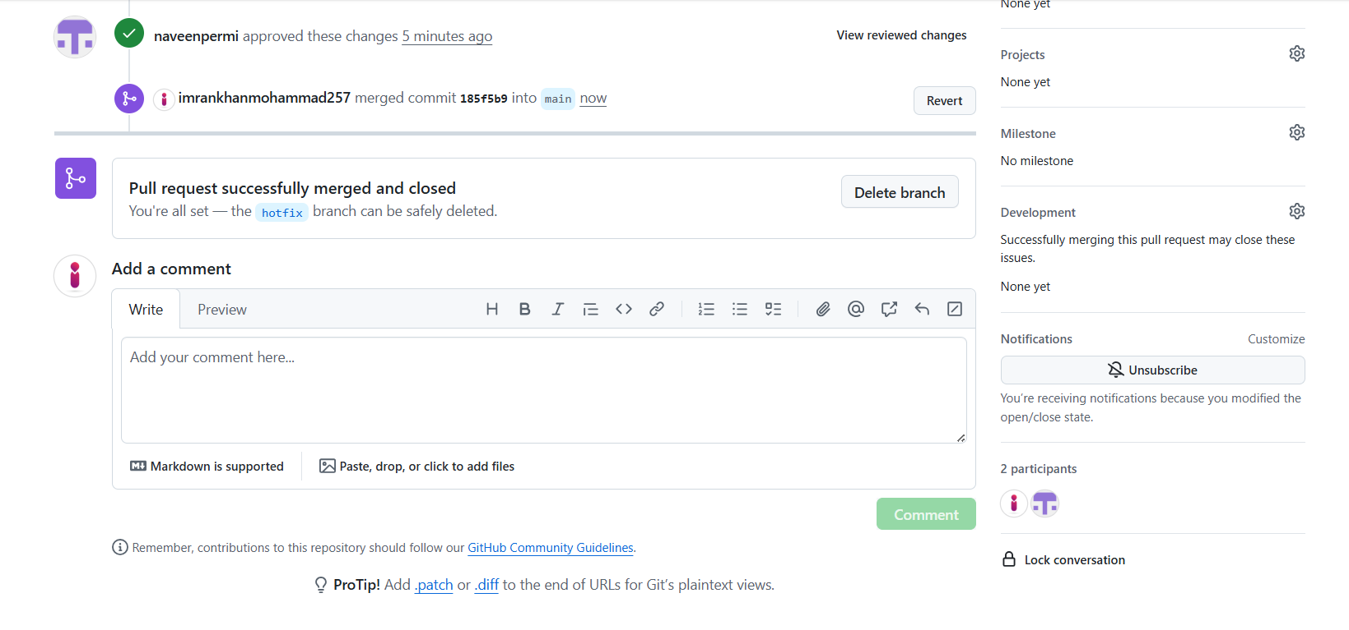

**10)create a file in local and send that to branch in github.**

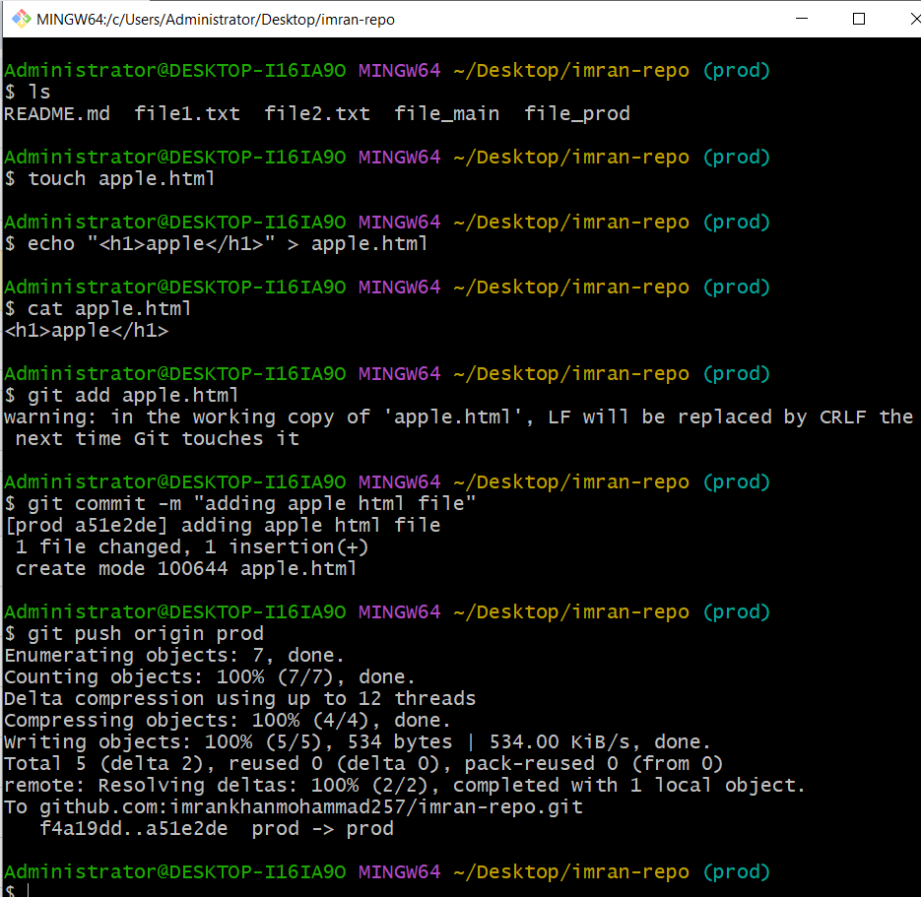

**11)clone only a branch from github to local.**

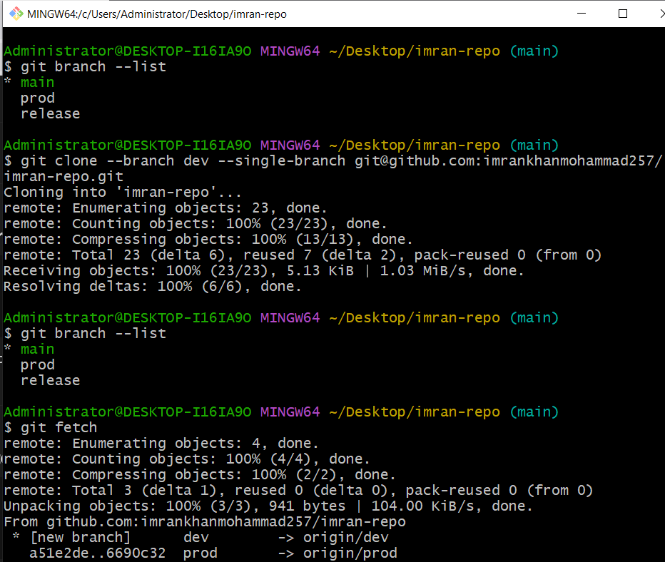

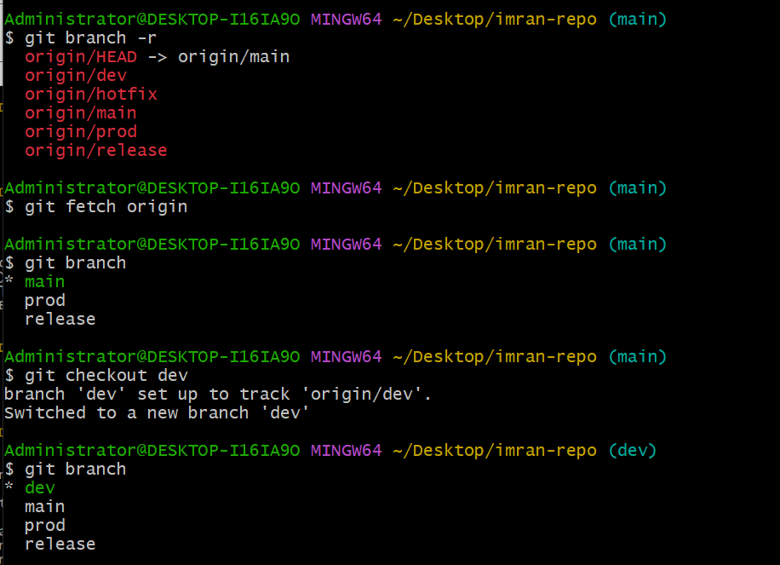

**12)create a file with all passwords and make that untrackable with git.**

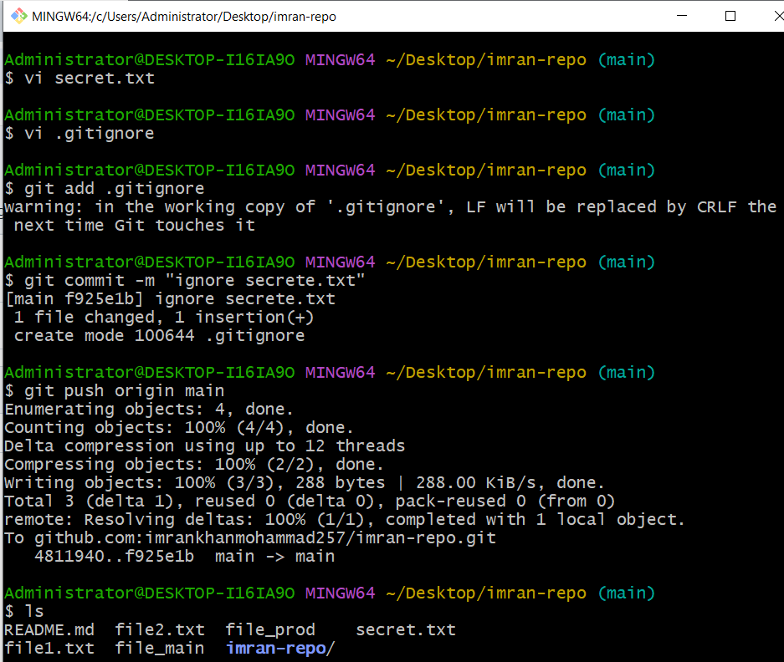

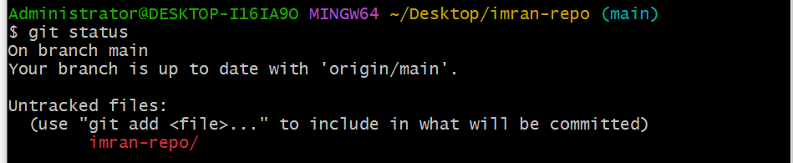

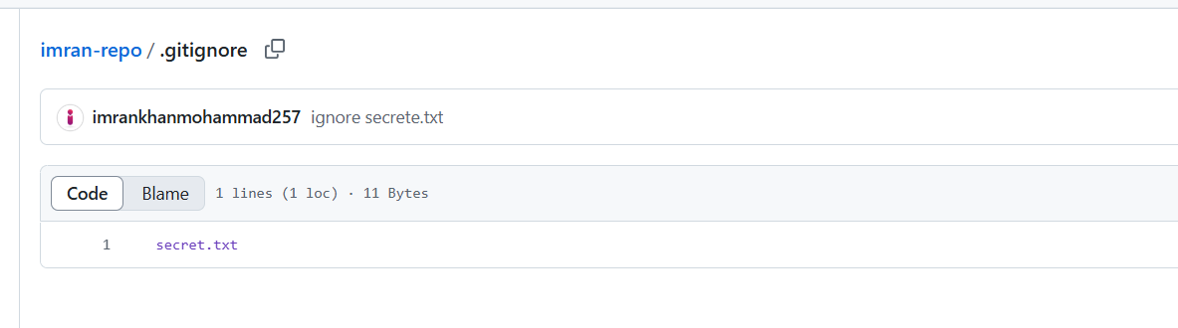

**13)make a commit and make that commit reset without savings changes.**

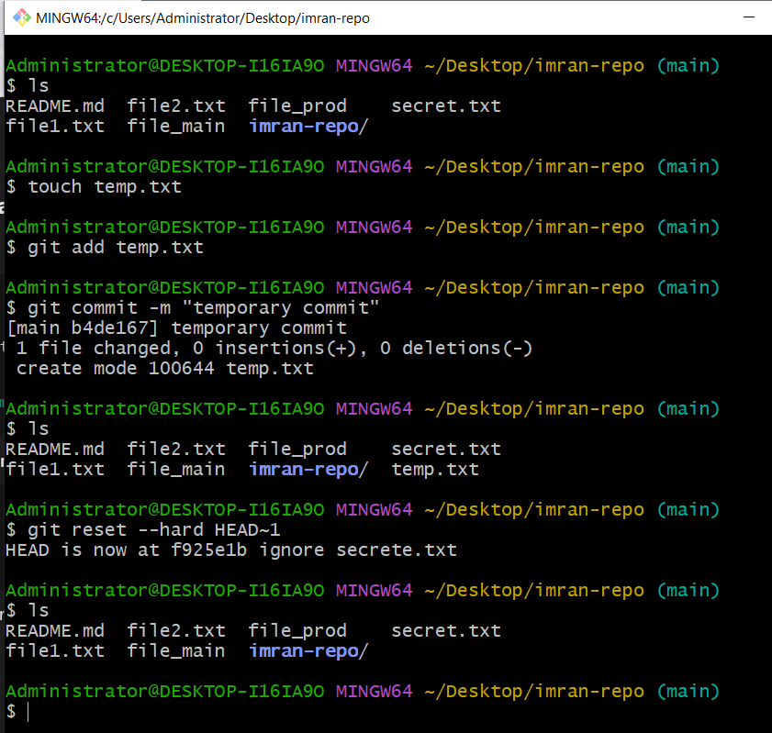**0**

**14)Revert a commited commit to the older version.**

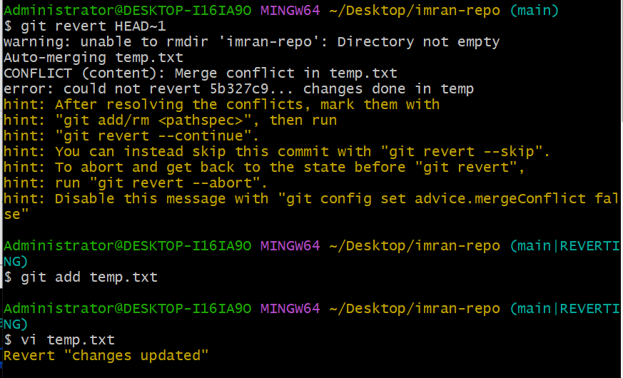

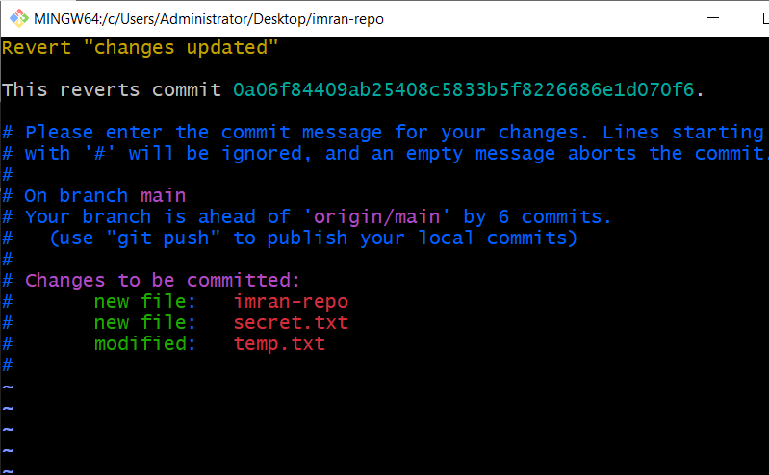

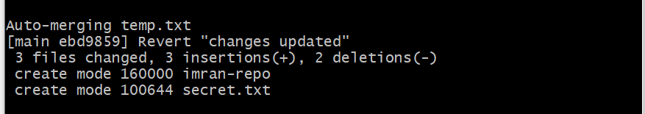

**15)push a file to stash without savings the changes and work on another file.**

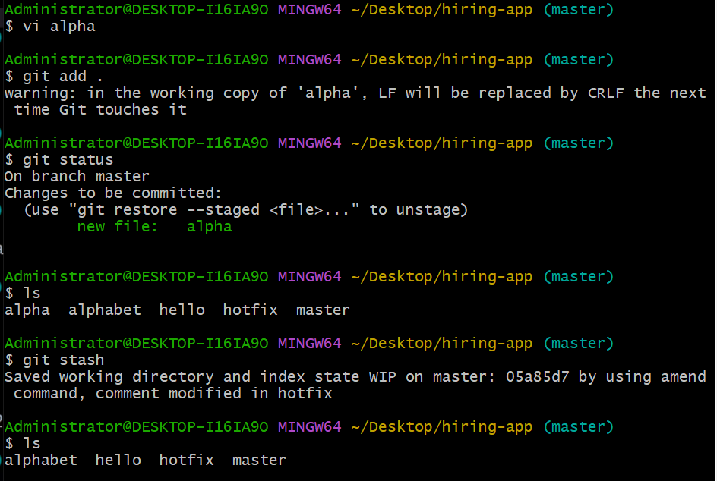

**16)undo the stash file and start working on that again.**

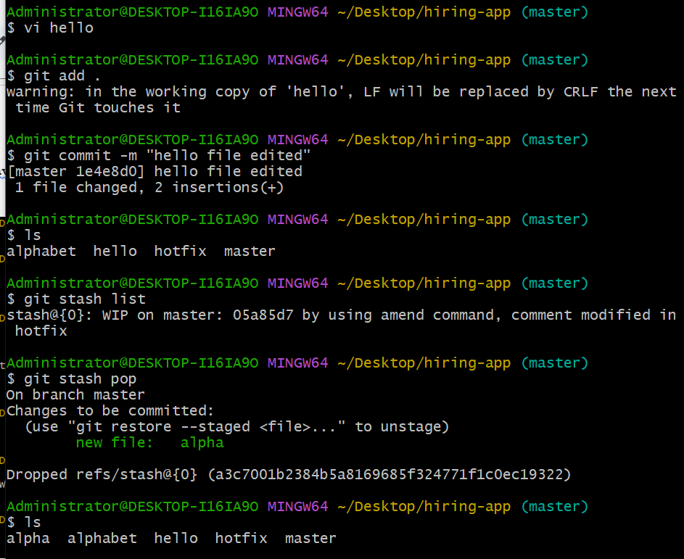

**17)generate a ssh-keygen and configure into github.**

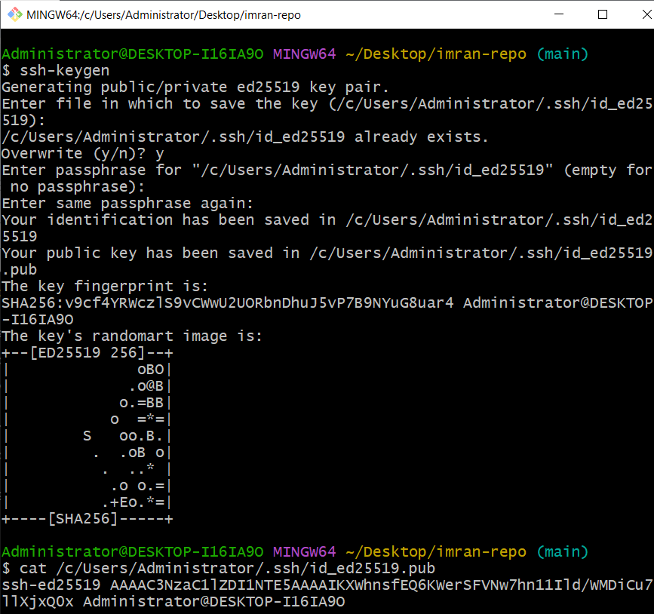

#### **Add to GitHub:**

* **Go to GitHub > Settings > SSH and GPG Keys > New SSH Key**
* **Paste the copied key**
* **Give it a title and Save**

**18)configure webhooks to github.**

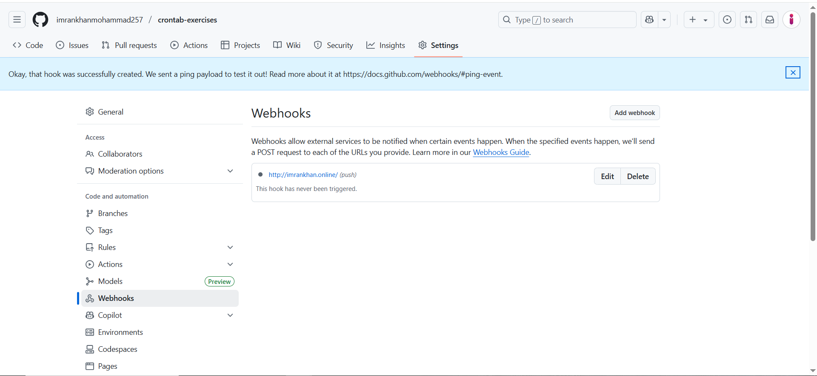

**19)basic understanding of .git file.**

**When you initialize a repo (git init), Git creates a hidden .git directory in your project.**

**This folder contains:**

| **Sub-folder/File** | **Purpose** |
| --- | --- |
| **.git/config** | **Repo-specific config (remotes, branches)** |
| **.git/HEAD** | **Points to the current branch** |
| **.git/objects/** | **Stores all commits, trees, blobs** |
| **.git/refs/** | **Contains branch and tag refs** |
| **.git/hooks/** | **Client-side hook scripts** |
| **.git/index** | **Staging area** |

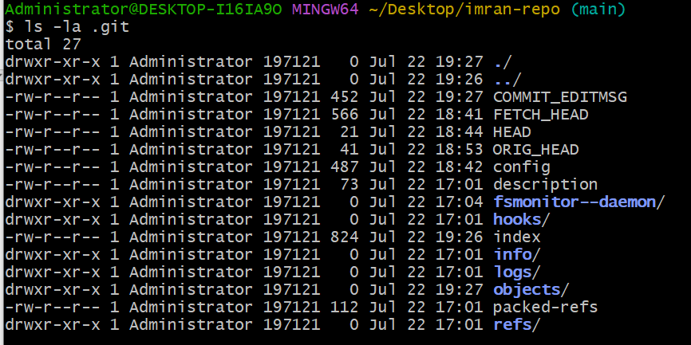

**20)Check all the logs of git.**

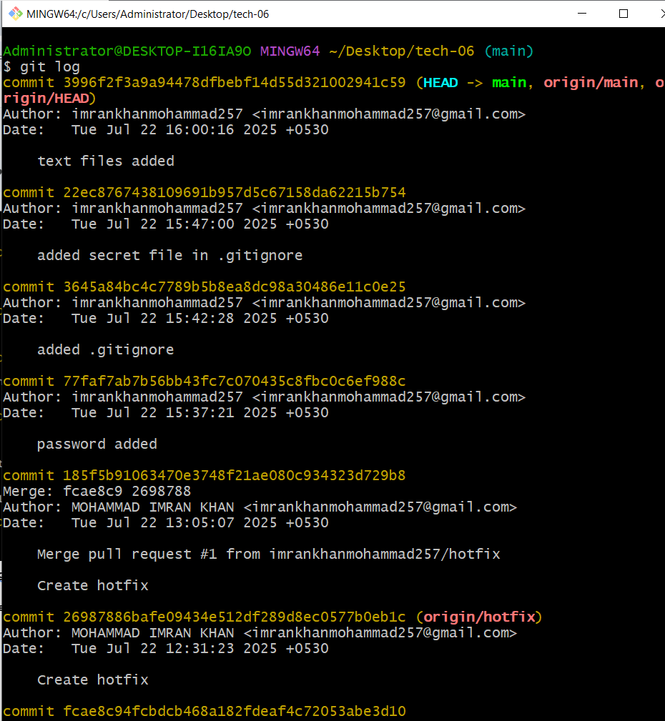

**21)Rename the commit message.**

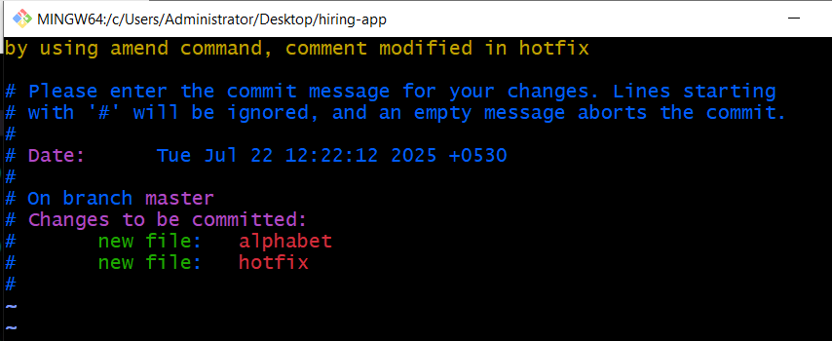

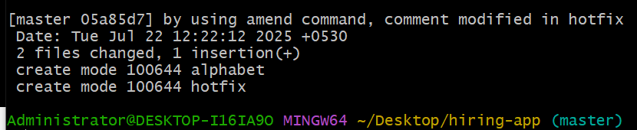

**22)Merge multiple commits into single commit.**

**$git rebase -i HEAD~4**

